Date: 3-january-2026 new year first day, 1/3/2026
Issue: recursion wale me issue tha. Ab isko while loop se krna pdega.
To ab isko while loop se krne wala kaam
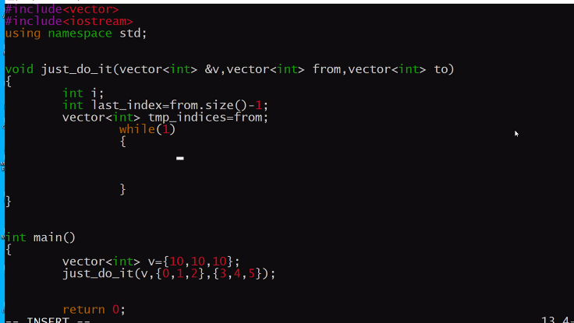
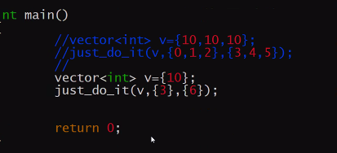
Ye esa function design kra pdega
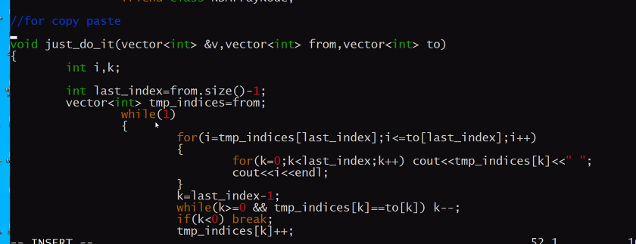
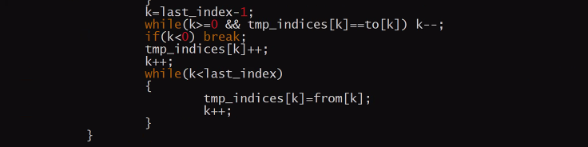

Ab next fill wala function likhna he:
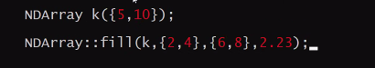
Logic: k wale array me from and to k saare elements me 2.23 fill krna he

Abhi pichle function me jaha pring kra he vaha tmp_indices ki value print kri he
Pichle wale function me ek issue he.

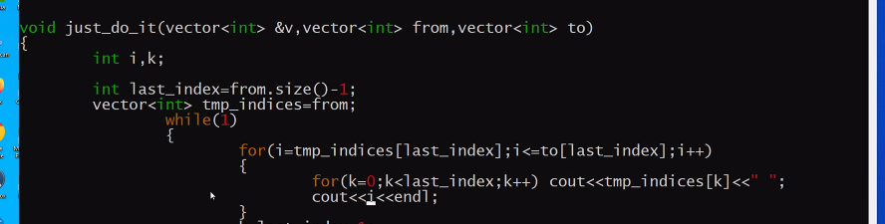
Ndarray me geindex() he usko updated array chahiye.
Abhi hum last me I ki value print kr rahe he.
Iski jagah esa hona chahiye
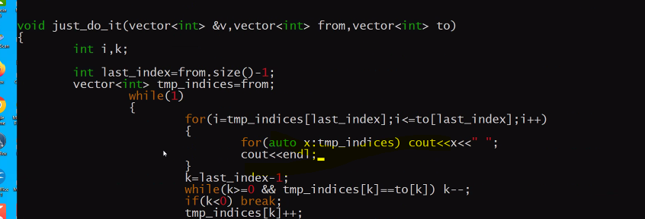
Ab final esa bnega vo
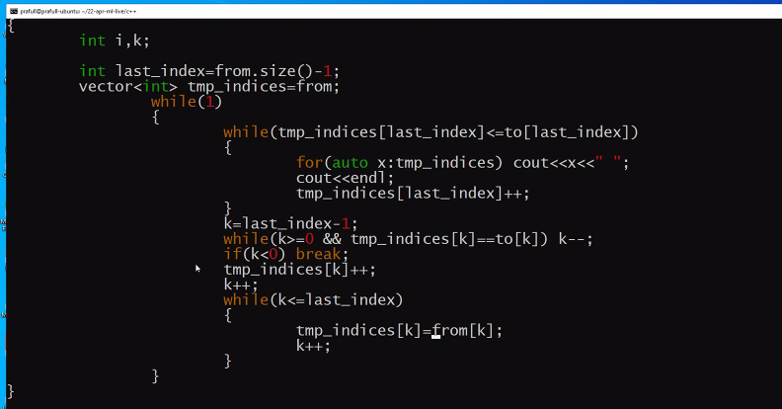
Ye vector ko lekr poc se he , ab isko ndarray me copy kr k use krega.
Next ab fill ki baat.
Ab user fill () ese use krega
To iska Prototype:

Ab ndarray me getindex() naam ka function nahi he, to bnana pdega, vo ndarraynode k getindex() ki hi copy hogi.
ye esi bnegi.
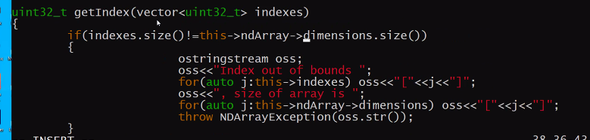 validations require he kyuki saamne wala fill krte waqt kuch bhi paas kr skta he.
Ab fill me getindex ko call kiya and indices paas kiya
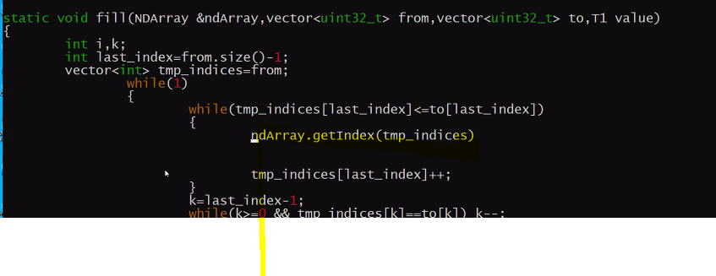
Vo ya to collection return krega ya exception raise krega.

Ab vo jo propotype bnaya justdoit ka usi ko copy kr k fill bnaya ab usi ko copy kr k print bnnaate he.
Isme from and to bnaya and niche ka logic same.
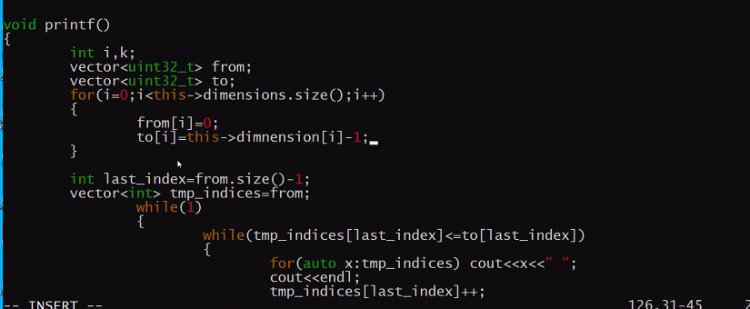
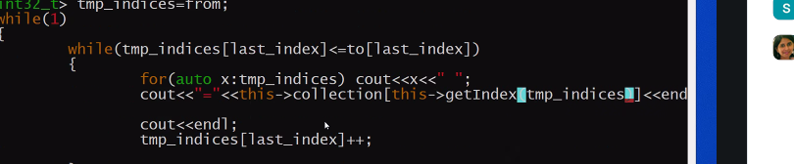ye index k sath value print krne ka kam.

Next: an copy k bare me sochna he.
Source from and sourceto and destfrom destto.
Print me to from and to hi hota he but copy me source and to dono aaege

AAj ka ss: 3 january ka screenshot. SS

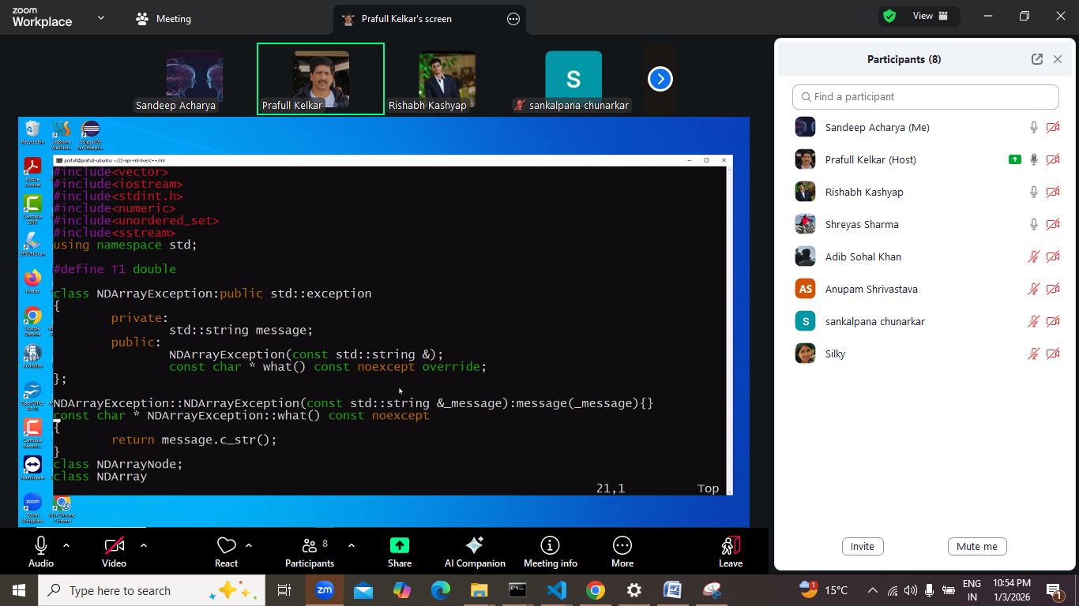
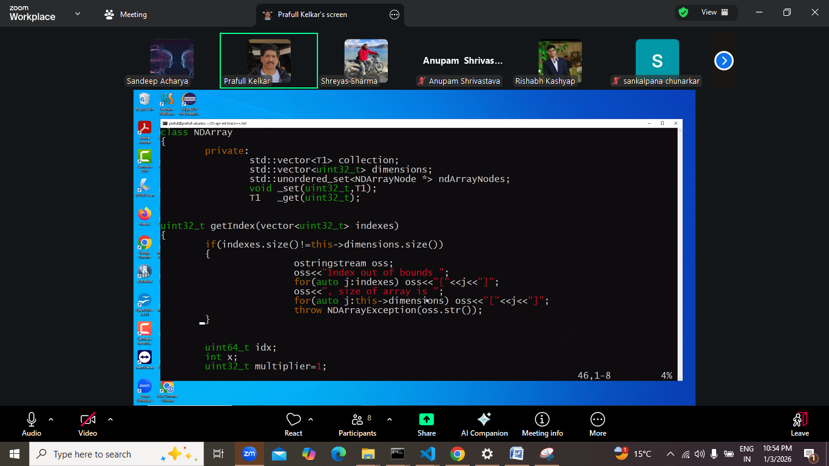
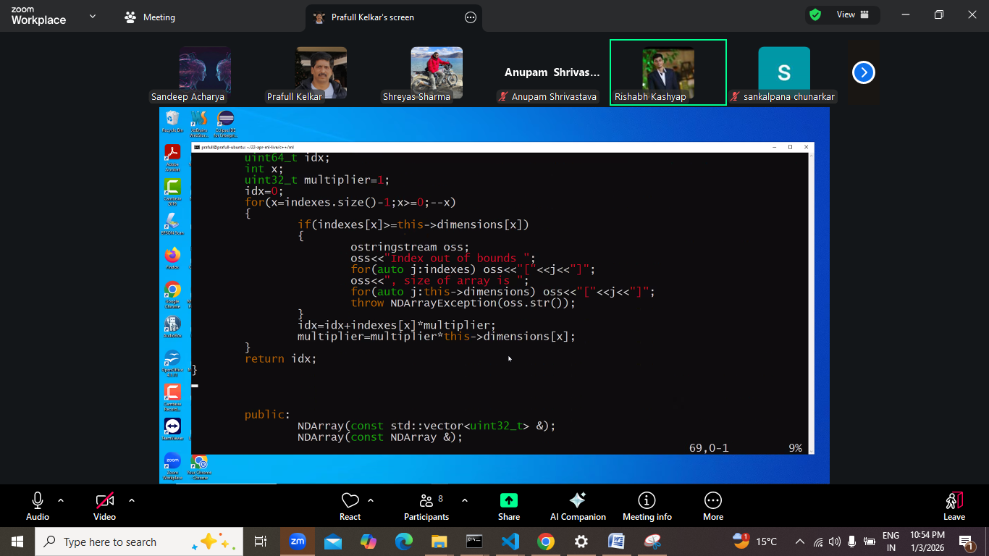
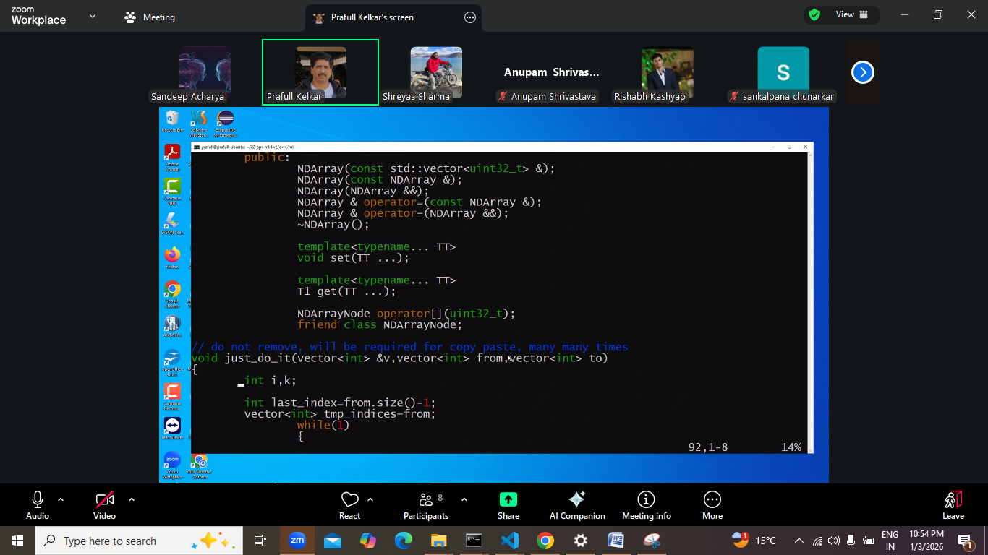
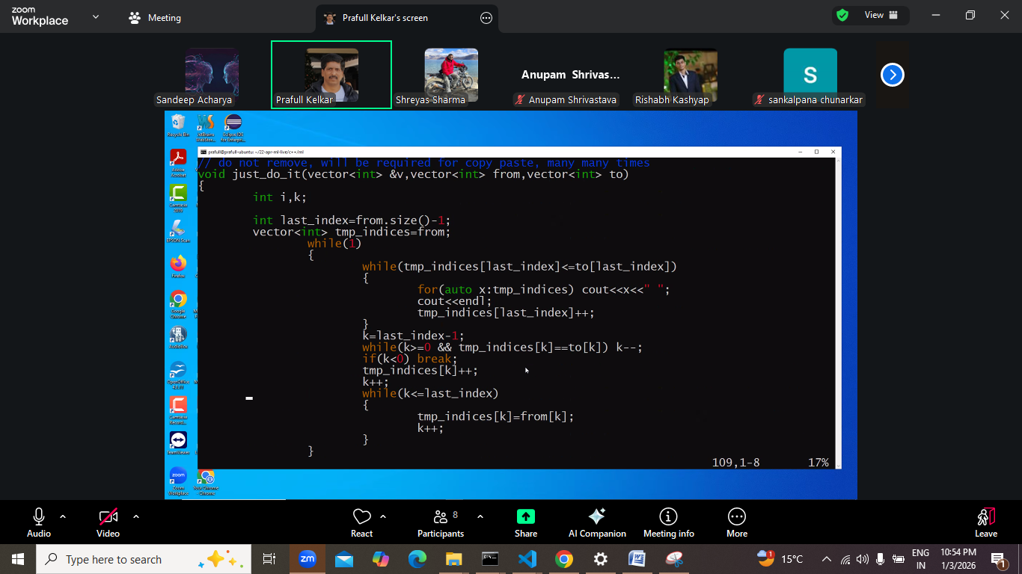
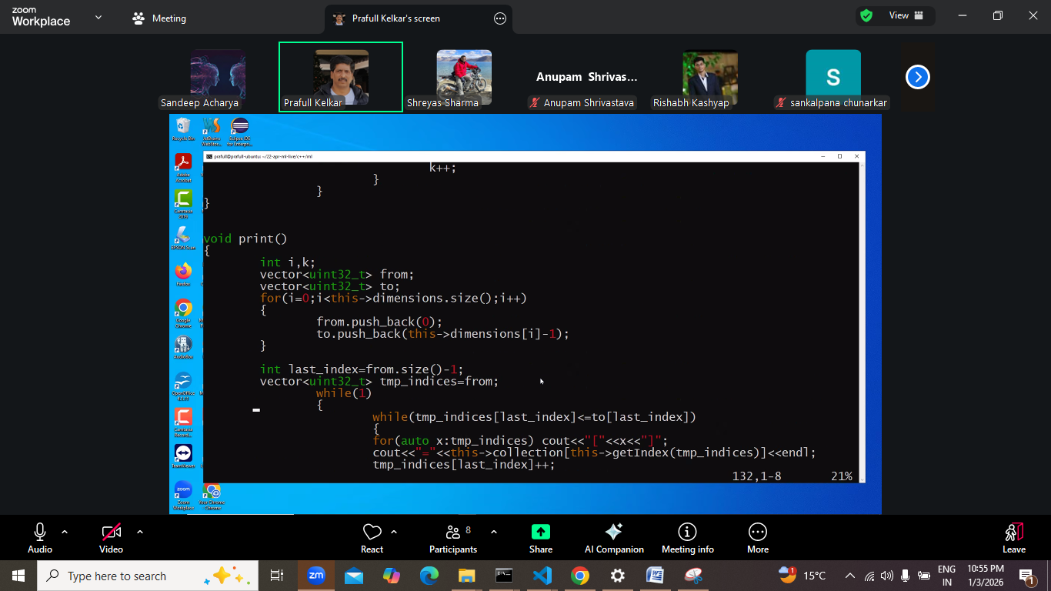
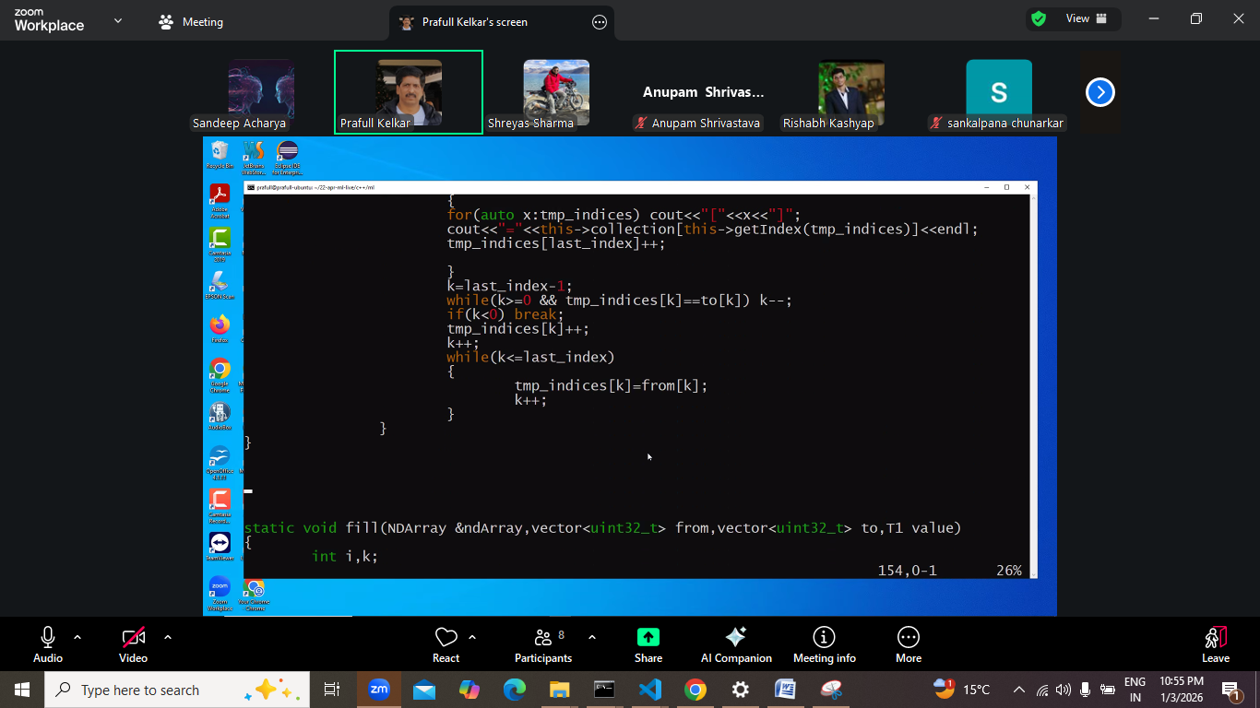
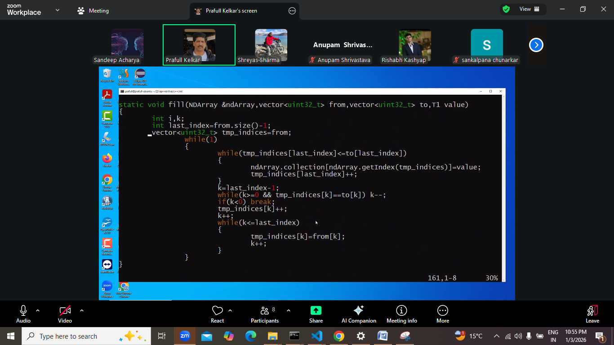
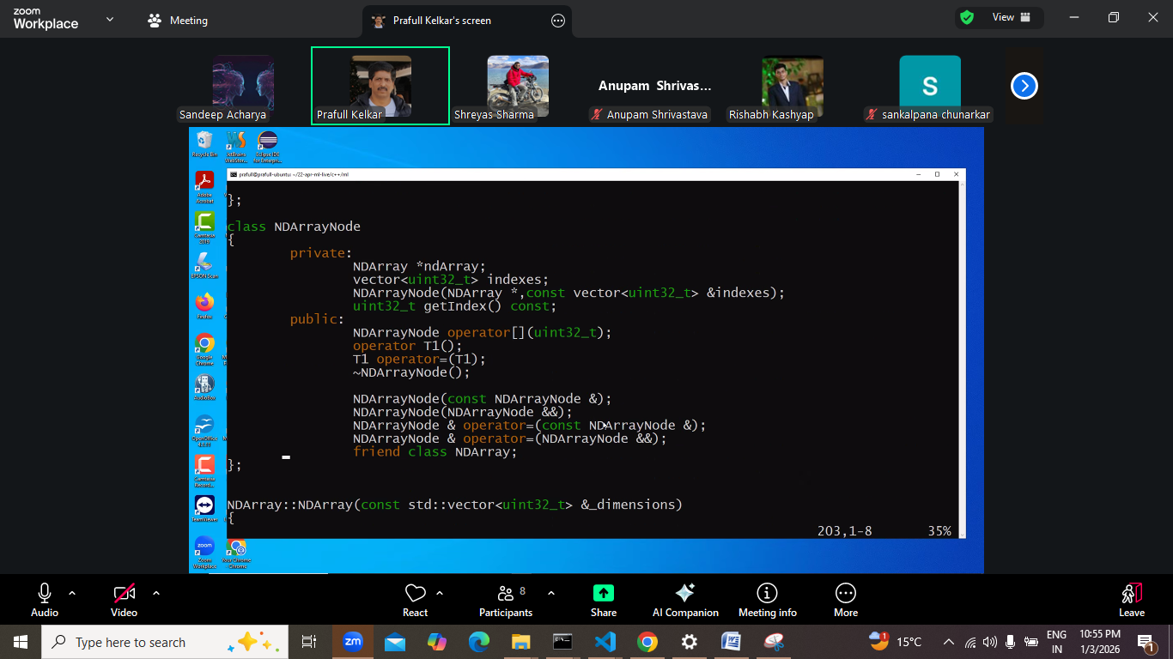
Ab baaki niche kcih chan nahi ab sidha main.
POC:
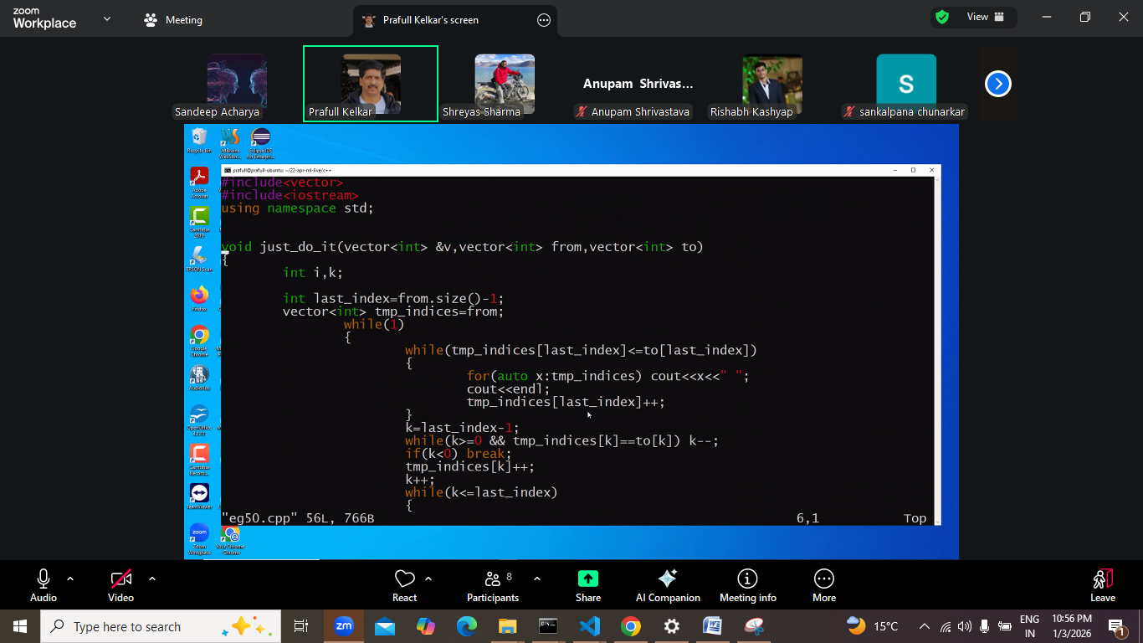
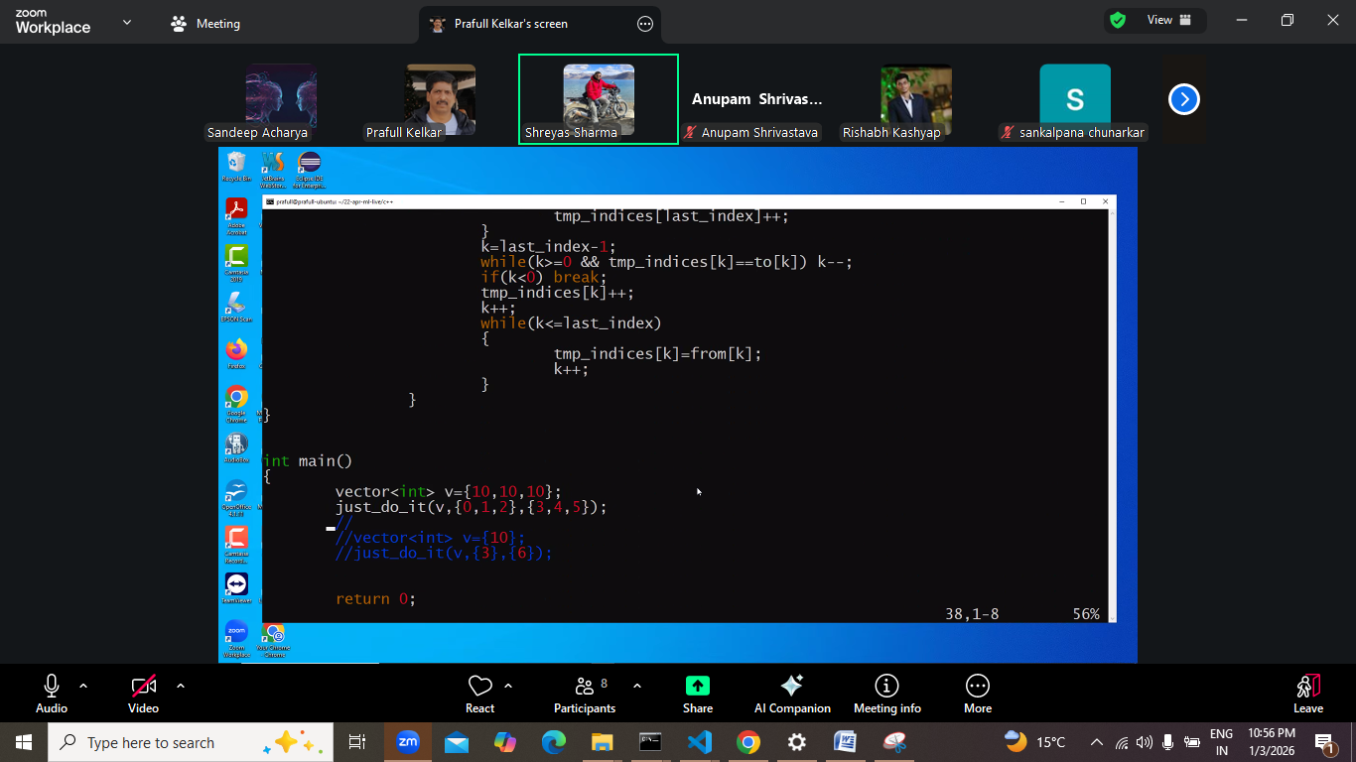

Ask from sir:
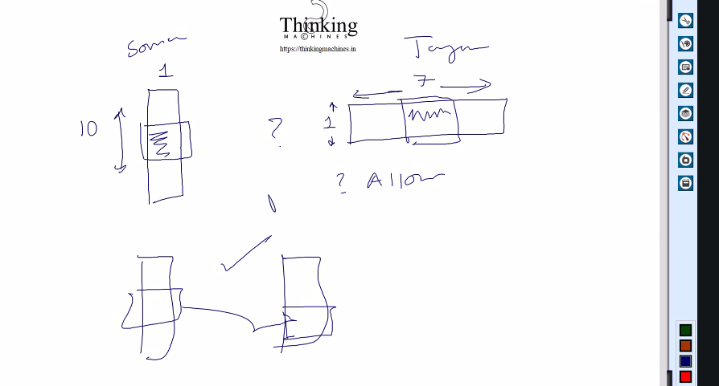

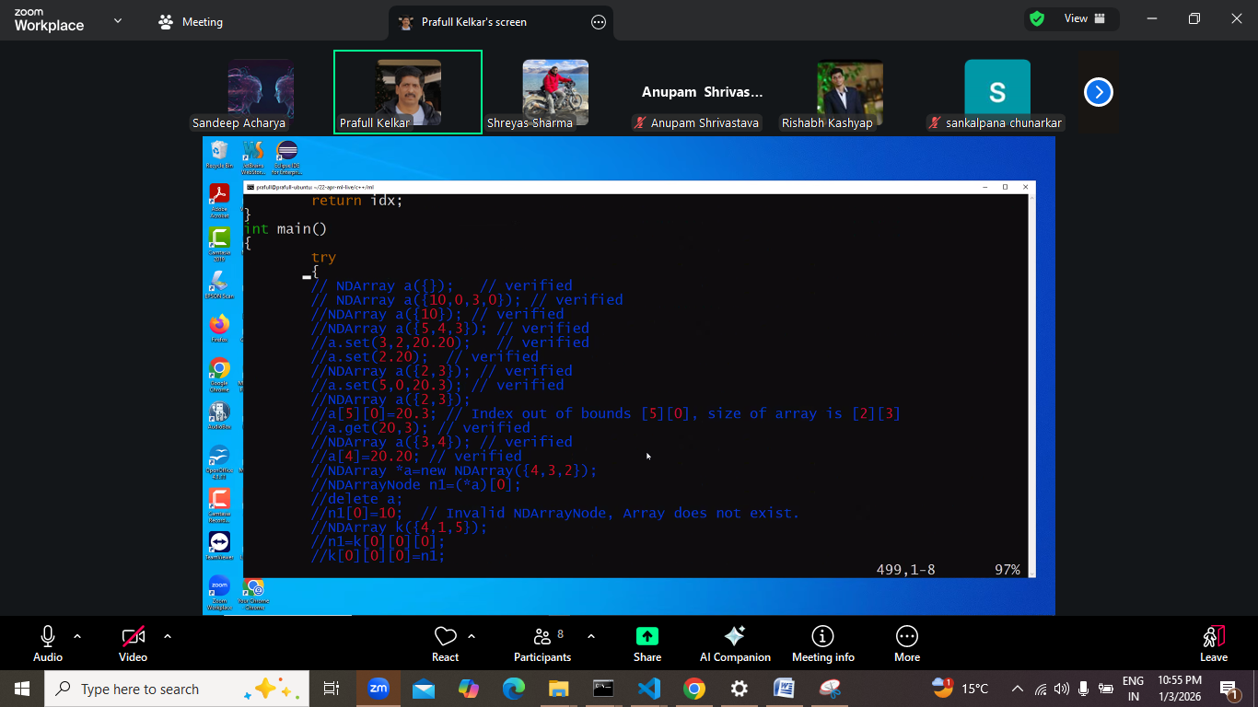

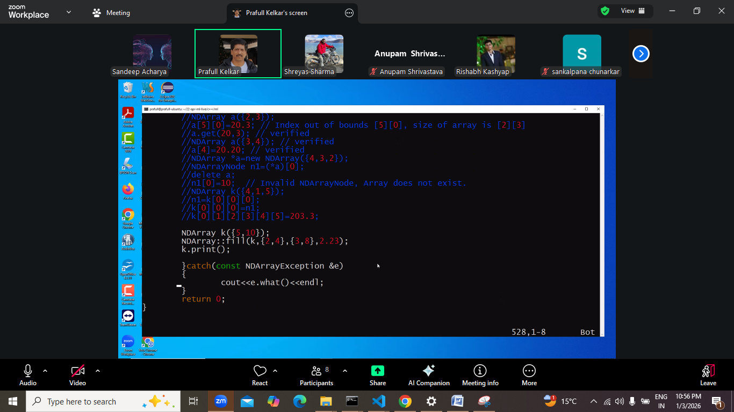

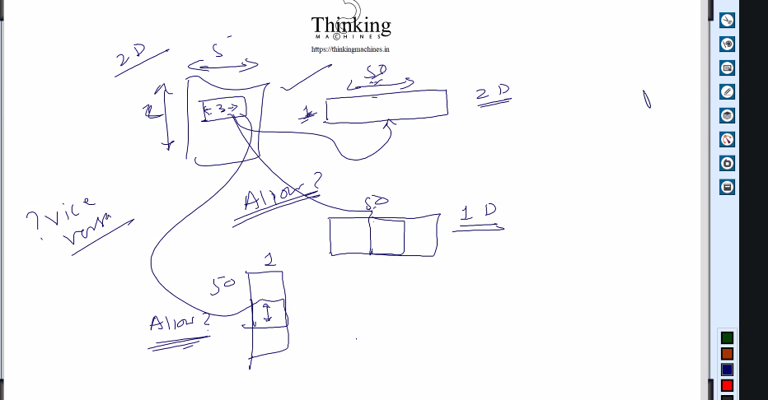 allow krna he kya.
Next:
NDarrray ki slicing kint e tarike se ki jaa skti be
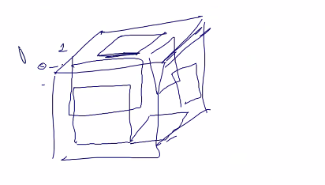
NDarray ko Kese bhi kaat lo group of rectangle hoge.
Ab us rectangles k bich copy krne ki baat aa rahi he, unko allow krna he kya.
NDArray bi bnai claas he kisi tech me , unhone kese allow kiya he ye bhi dekhna he.

Date 8 january 2026 , 1/8/2026
Ek general discussion:
Hum 2015 se 2020 me he , jo hum baat kr rhe he
Hum abhi job hi kr rahe he vo sn llm+
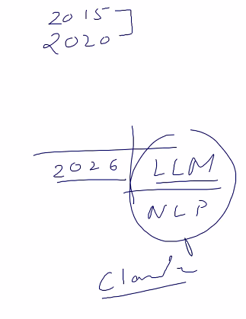
Code bnaye jaa rahe he claude k through and python ki chain lib k through.
Pr sb llm and nlp ka combo he.
Pr jb code fatta he to halat khrab ho jaati h.

2020 me research paper likhe and gpt-2 bnaya and labling k liye sabhi gaanv k logo ne data diya.
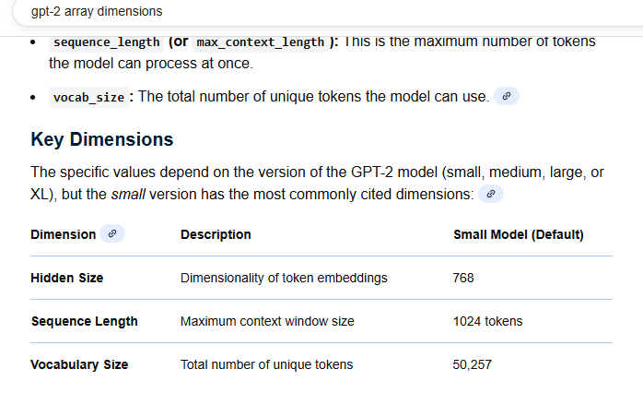
Phir kisi ne ndarray bnaya.
Phir :
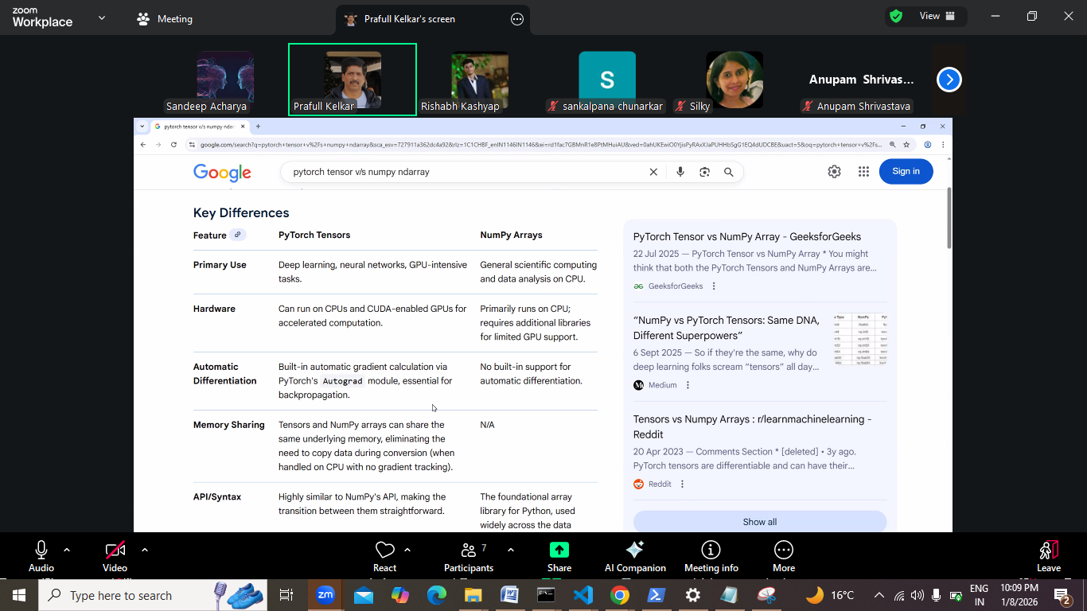
Iske difference dekh k pta chlta he. Puri table dhyan se pdo.
Agar hum llm ki theory pdege to :
Storage + procession power chahiye + python+ lib use kre to llm model bna skte he.
Dekha jaye to abhi jo hum kr rahe he vo waste of time he.

Also llm k license kharido to model train bhi nahi krna pdega.
Agar in house model bnana he to phir ye saari process aana chahiye.
To humko in sb k bare me pdte rhna he,
Llm tk jayege.
Abhi hum infra bnane me lge he.
Pyton pr jayege to infra nahi bnana pdega.
Sath me parallel programming :
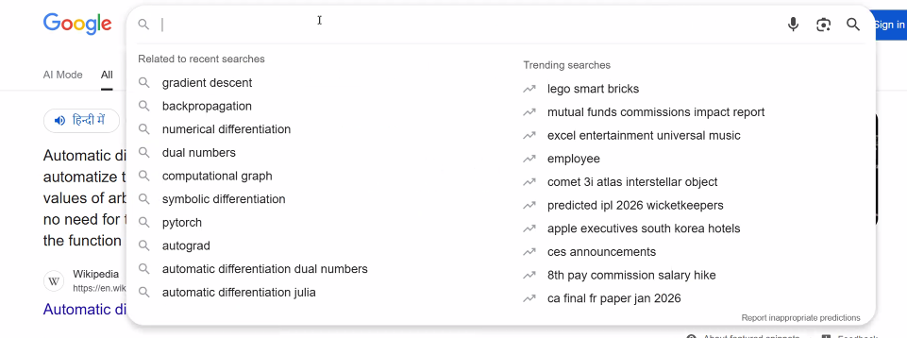
Llm k upar kuch pdte raho, pr us context me nahi pdna he ki humko kuch leke assemble krna he.

1d 2d 3d to dimang me rahega.
Max 4d tk jaa skte he.

Next:
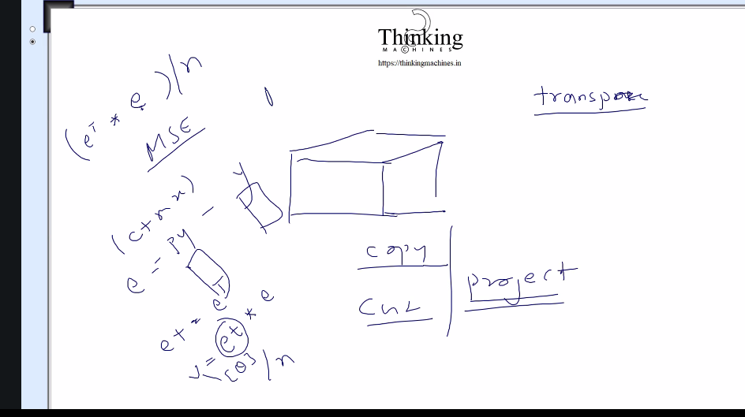
Transpose k liye virtual ndarray bna le jo ki transpose version of e ho.
Uske andr jo collection hoga vo E k andr k collection ko hi use krega.
Ek or jhanjat aane wala he: humne container bna rkhe the taaki loop me baar baar memory allocate na ho.
But idr cpp me to
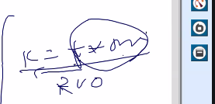
T k liye jo * operator chlega.tb memory copy hogi.
Agar 1lakh training cycle chl rahe he.

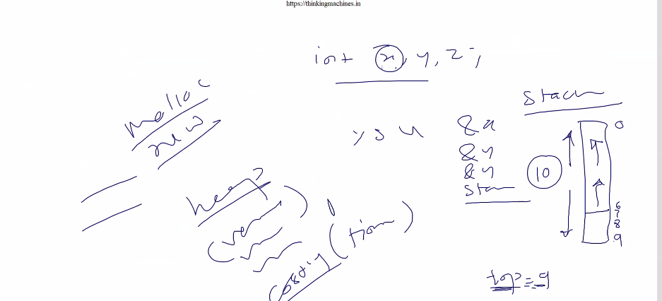
Malloc se heap pr memory hogi and heap wali very very costly.

Copy ka analysis: source and target.
- Dono 1D not issue
- Source 1d target 2d ,3d 4d: allow krna chhiye ya nahi.
Isme kya issue aa skta he, ek 5 element ka 1D array 0 se 4 .
Target me column me copy krwana he ya row me copy krwana he?
Copy as column ya copy as row dono allow krna he.
But withing boundry aana chahiye
Validation esa he ki target me itni space honi chahiye , hum truncate nahi krege and exception raise krege.
- 2nd ka vice versa: allow krna he , 2d se 1 patti 1D me
- Source 2D and target 2D:
  - Hum thoda soch k ruk gaye , reasearcher ne 22 ghante socha hoga tb hi to kuch bna paye
  - 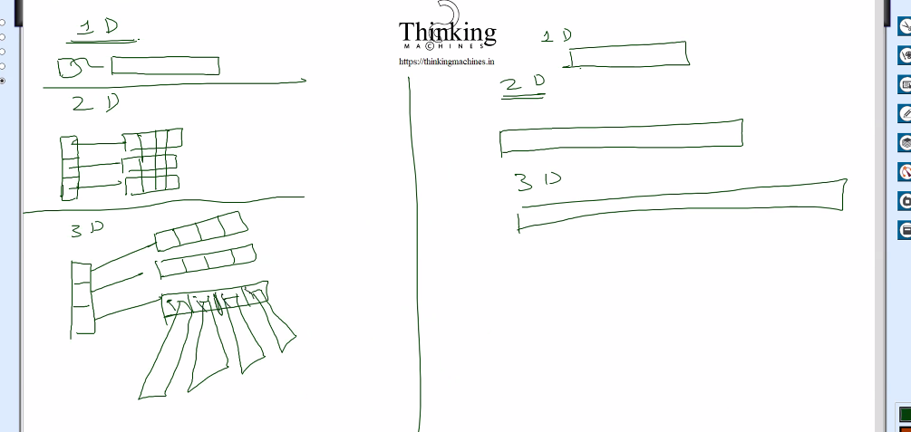
  - Typed ka issue:
  - 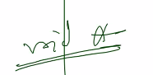
  - 4D me 3d wali paati me pointer and har pointer me data wali patti.
  - Void * le liya to vo math int++ wala features nahi
NDarray walo ne kya kiya hoga: hum log me bhi to dimag he , humko jo problem aa rahi he vo unko bhi to aayi hogi. Unhone bhi to scenario soche hoge.
3D me se 3D nikal nahi skte pr 3D me 2D nikal skte he
But humara mn ye sochne k liye taiyar nahi he ki can 3D extract from 4D.
Torch GPU ka spport krta he to unhone data structure esa bnaya hoga unhone ki parallel support kre.
Jese matrix multiplication is like multiple times vector multiplication.
क्या 4D में से 3D निकल सकता है?
हाँ, गणितीय रूप से एक 4D वस्तु (जैसे Tesseract) की "सतह" या उसकी सीमाएं (Boundaries) 3D होती हैं। 3D and 4D Geometry - Wikipedia
- जिस तरह एक 3D घन (Cube) की दीवारें 2D वर्ग (Square) होती हैं।
- उसी तरह एक 4D 'हाइपरक्यूब' की "दीवारें" 3D क्यूब्स होती हैं।
- अगर आप 4D स्पेस से एक 'स्लाइस' (Slice) काटें, तो जो हिस्सा हमें दिखाई देगा, वह 3D ही होगा।

Humko 3d se 4d me copy
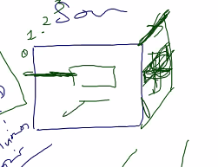

4d se 3d se nikalna he and 3d ko 4d pr chipkana he.
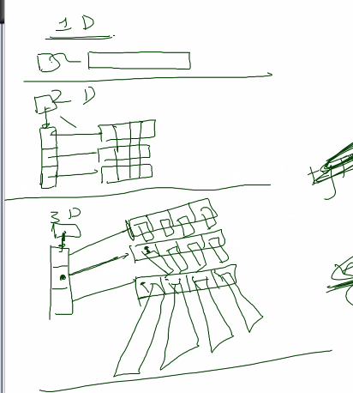
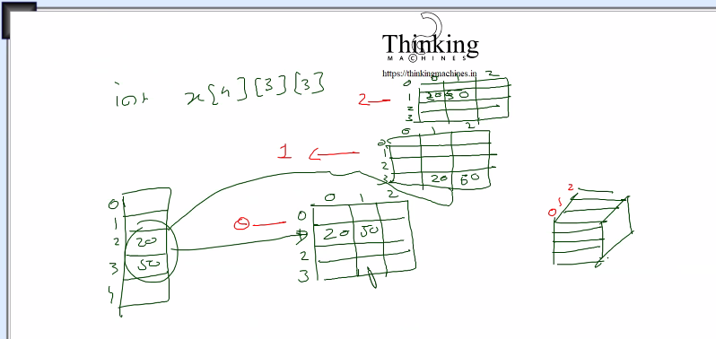
Pr jhgda ye he ki
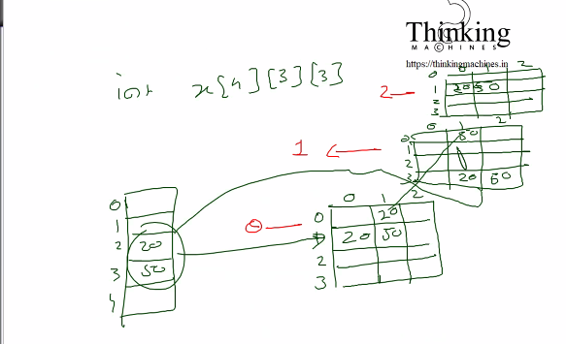
Ye 3 chipke hue 2d array he.
2d me chipke hue 1d array
4d me chipke hue 3d array.
Alag alag layer me allow krna he kya?
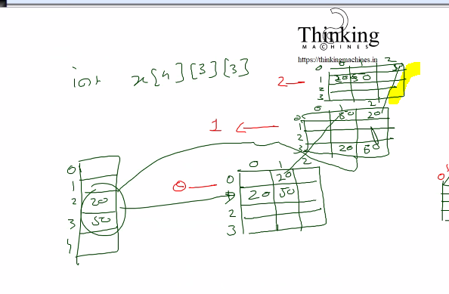
Ab niche k face me:
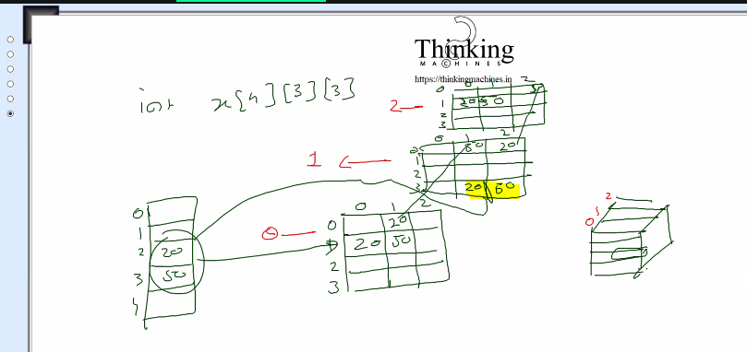
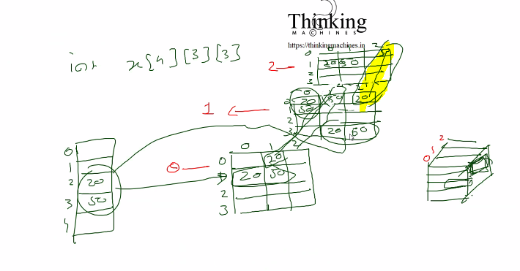
Ye right face.
Esa diagram bnayege to chize clear hogi.

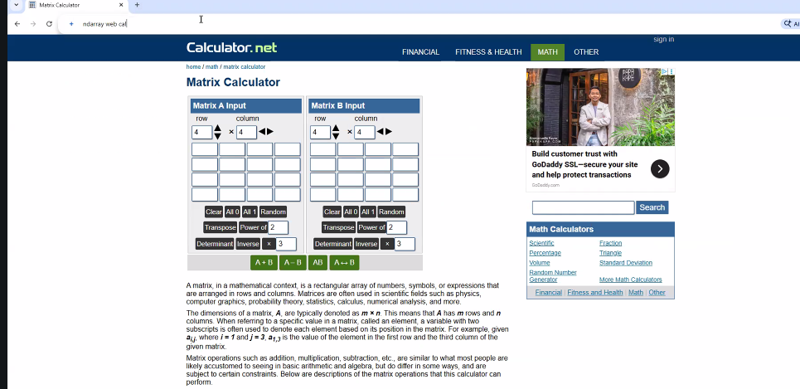
Web interface to faltu baat he ,
Saal k 30000 for a ec2 godady , jisme os hum jo bolege vo dalega
And uske baad login kr k ho icchha ho vo web server daal do
Front end se data leke us
24000, ssl k 4000 and domain name k 2000
Generally log heroku pr daalte he.
Cloud platform k liye nahi jaana , and control humare haath me lo humari marji pde vo install kre.
Maan lo hmko java aata he and jni ka example dekhege to boundry
Pr without aws humare khule hath , aws k case me bnadh jayege.
Corporate world k liye cloud platform pr deploy kr k chhod de.

Next session ye workout krna he.

Next session is on 15 jan 2026

Date 1/15/2026 january 15 2026

Next session kuch study krna he ki initialization ese krte to kes rhta
S={10,20,30,40,50}
2d me s= {{},{},{}}
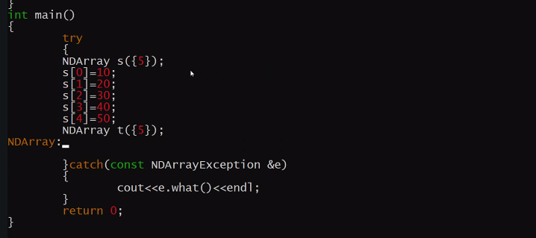

Ab next:
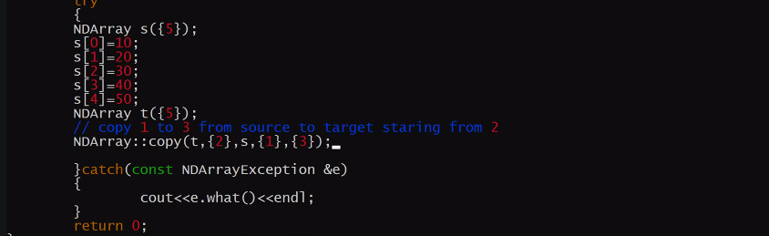
Ye achieve krna he
Parameter ko convert krege
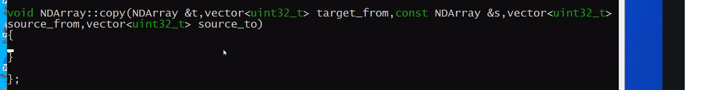
Abhi validation nahi kr rahe he ,to abbhi target_to compute krne ki jarurat nahi he.
Loop ek hi lagega only source and targe k indexes k liye variable change hoge.
Abhi isko uthe k copy() bnayege
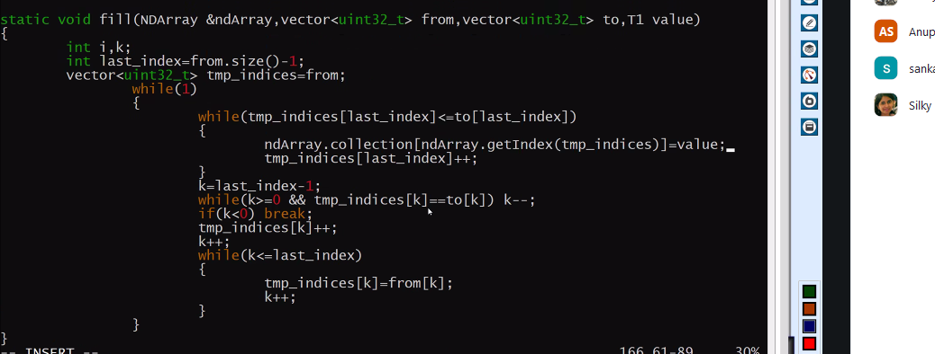
Only value ki jaga source se pick kr k assing krni he.
Iske from and to ko sourcefrom and sourceto bna dege.
Humko value set nahi krna us jagah blki us jagah se value uthana he.
Ese
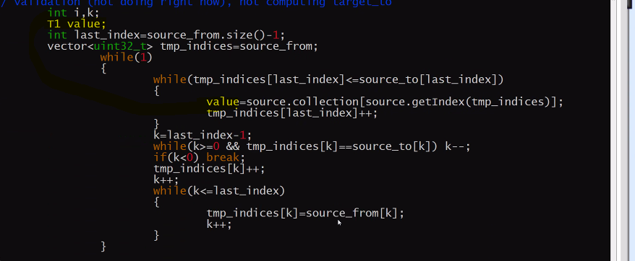
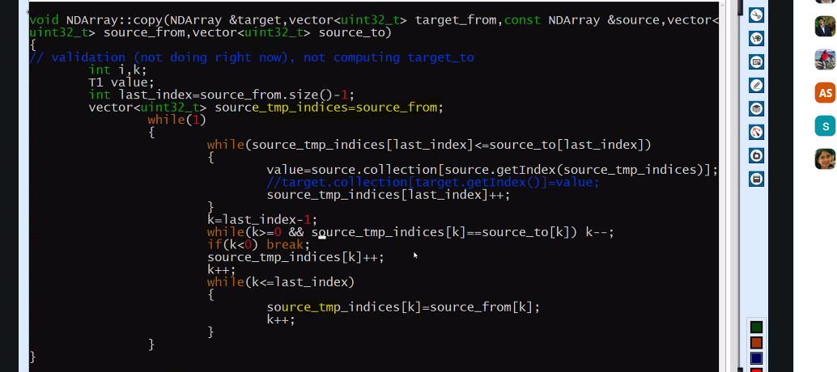
Sourcetmp indices liyastarting point ko tmp me dala kyuki fix to rahega h I
And jo copy liye he usme change krte jayege and to tk jaana he.
Ek issue:
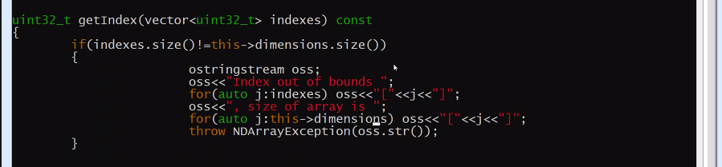
Yaha r getindex k aage const laga k bol rahe he ki iske pas job hi data aayega usko vo modify nahi krega
This will not muted the object anyway esa promise kiya.

Ek smjhne wali baat:
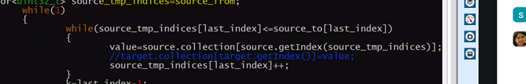
Indices vector k last index pr jo the usko from se to tk le gaye
Ab indices vector me ek ghar piche aa k us index ko from se to le jaana he
But ye check kiya ki us dono indices vector ka vo index same he to phir piche aa k dusre index ki baat krege.
Angr k minus chla gaya means saare index cover kr liye.
Nahi to
Isko baad me smjhte he

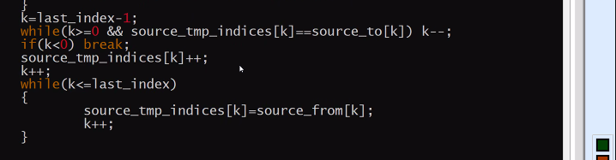

Ek or baat:
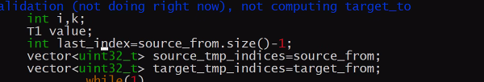
Dono ki size same hogi to last index kaam kr jayega
But in future me dimesion vary ho skte he , to lastindex dono k liye kaam nahi krege.

Testing ka testcase phle 2d k liye test krte he
:
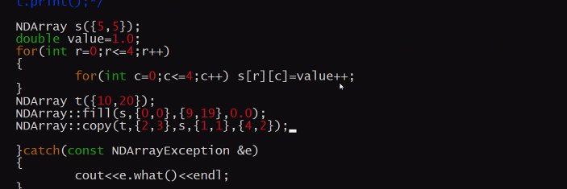

Ab humko sochna he ki
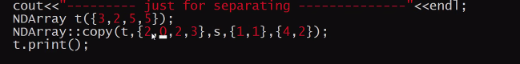
Vo 5 5 diya tha jb kya isse tha
{3,2,5,5} ko read krne ka tarika ,
Ek 4D matrix jiski size 3 , means isme 3 3D matrix
Ek 3D matrix jiski size 2, means isme 2 2D matriz
Ek 2D matrix jiski size 5 , means isme 5 1D matrix
Ek 1D matrix jiski size 5, means isme 5 element.
Means 3 , 2*5*5 ka matrix
2, 5*5 k matrix
5, 1*5 k matrix, 1d k case me size ko 1*n liya jaata he, as a row vector.

Abhi humara source 2d array he hum usme [1,1] se le k [4,2] tk ka material humare 4d array jiska size [3,2,15,15] he usme copy krna chahte he. To last me hi 2d he to 15*15 me copy hoga
Pr humko 4d and 3d wala index btana hoga
Like: 4D me decide krna hoga ki 0 ya 1 ya 2 [since index size is 3, to 0,1,2]
And 3D me decide krna hoga ki 0 yaa 1 [sinse index/axis size is 2 to 0,1]
Humne diya target ka [2,0,2,3]
Means 4D ka last wala 3D box, us last wale 3D box ka first wala 2D box, us 2D box me [2,3] se copy krna start krna he and [14,14] tk jaa skte he.
To yahi he nd ka logic
Humara assignment he ki isko dekh k vo copy wala logic rectify krna

Aaja ka ass:
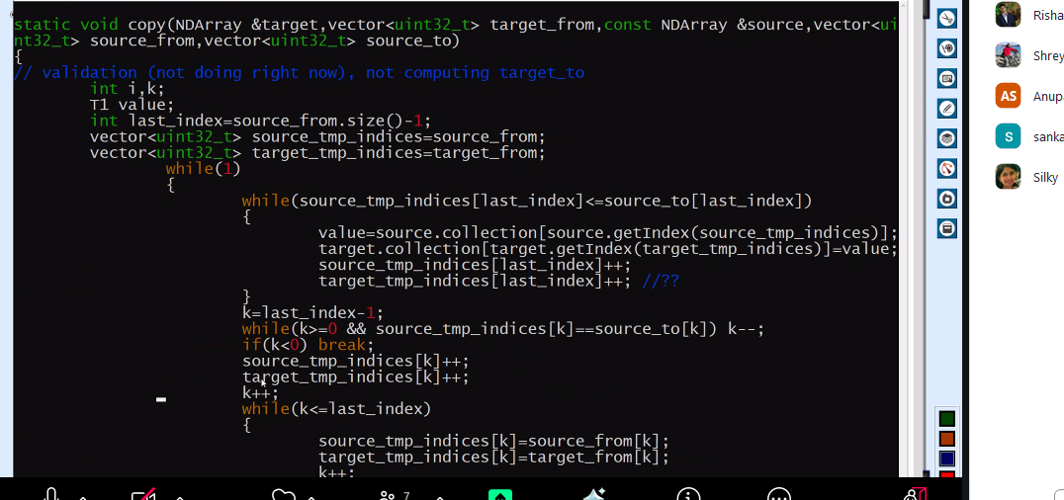
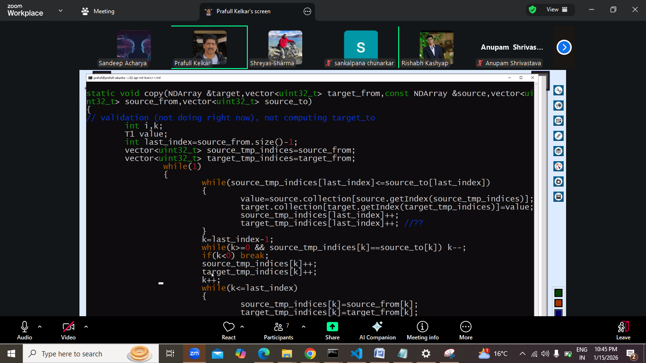

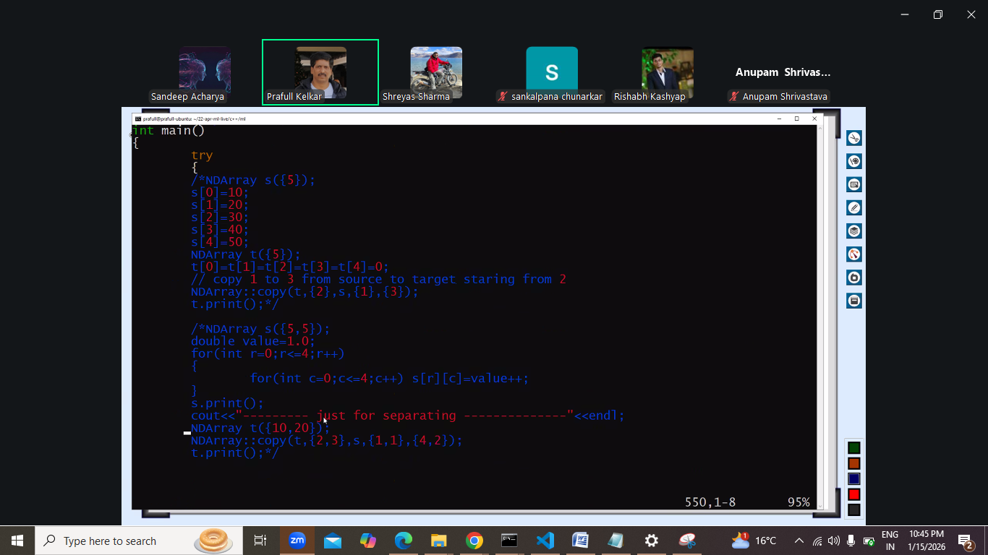
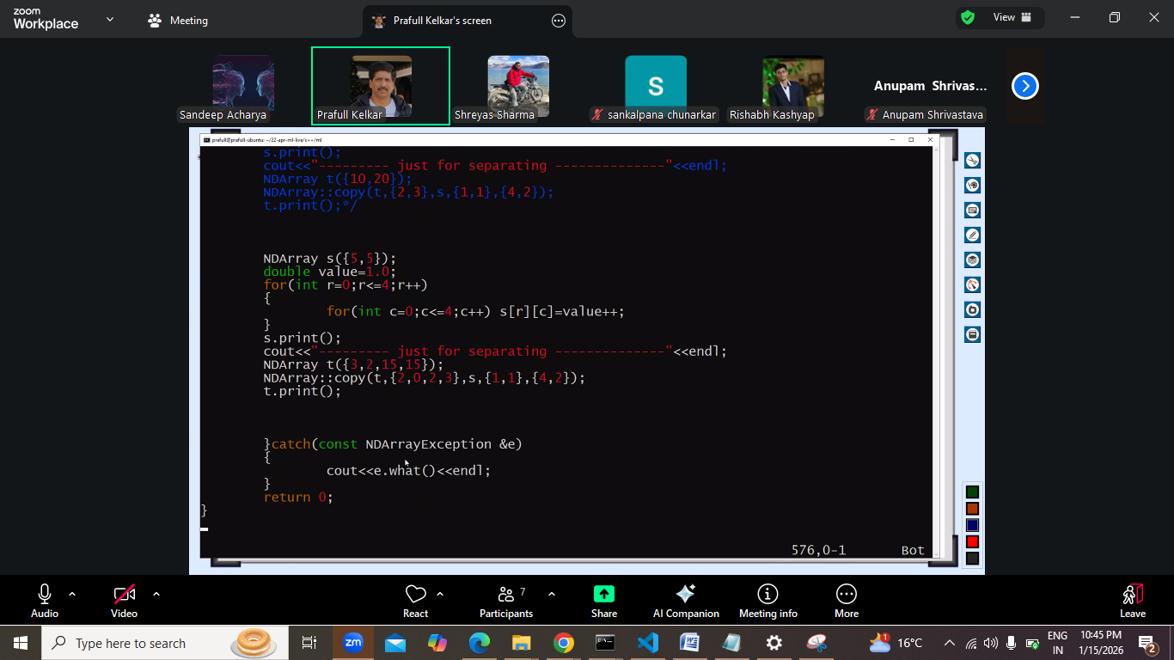

Question: kese algo ki practive krna chaiye
Question: just because humne multithreading introduce kr di that not sure

Thread
Context switching time khata he
2*n -1 thread chlega taaki har core k paas 2 thread rahe
And 1 thread for last core , but why?
Humara objectinve he matrix multiplication .
Parallel programming : kuda k liye nvidia ka graphic card lgega
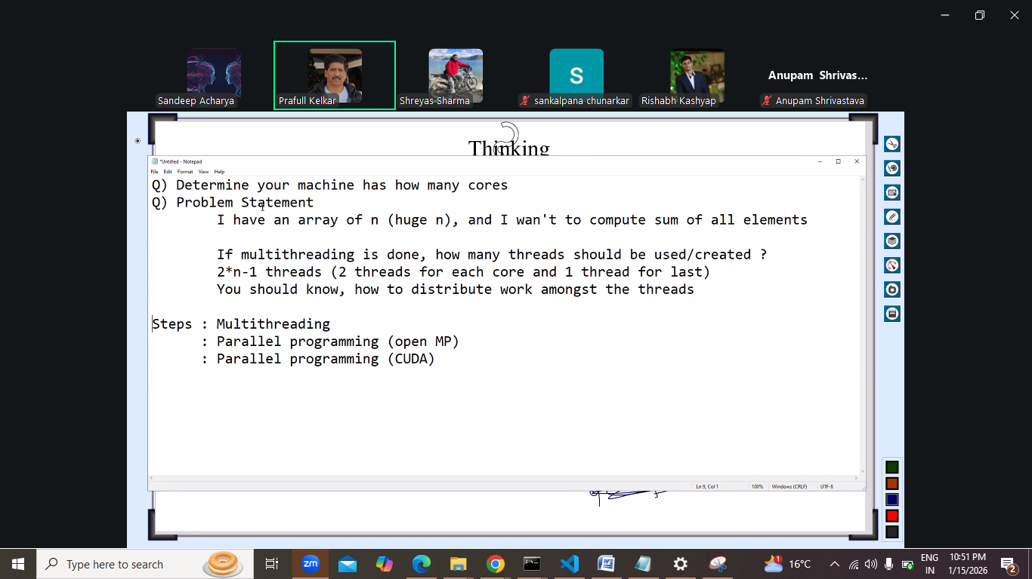
Abhi parallel programming ki baa nahi
Matrix multiplication k liye dono matrix readonly.
Read only me multithreading kaam krta he.
Images ka indexing krna tha amazon me to uske case me shreayas ne research kiya hoga
Ki kitne thread chlayee.

Next: 17-jan-2026, 1/17, 17 January 2026.
Issue ka drawing
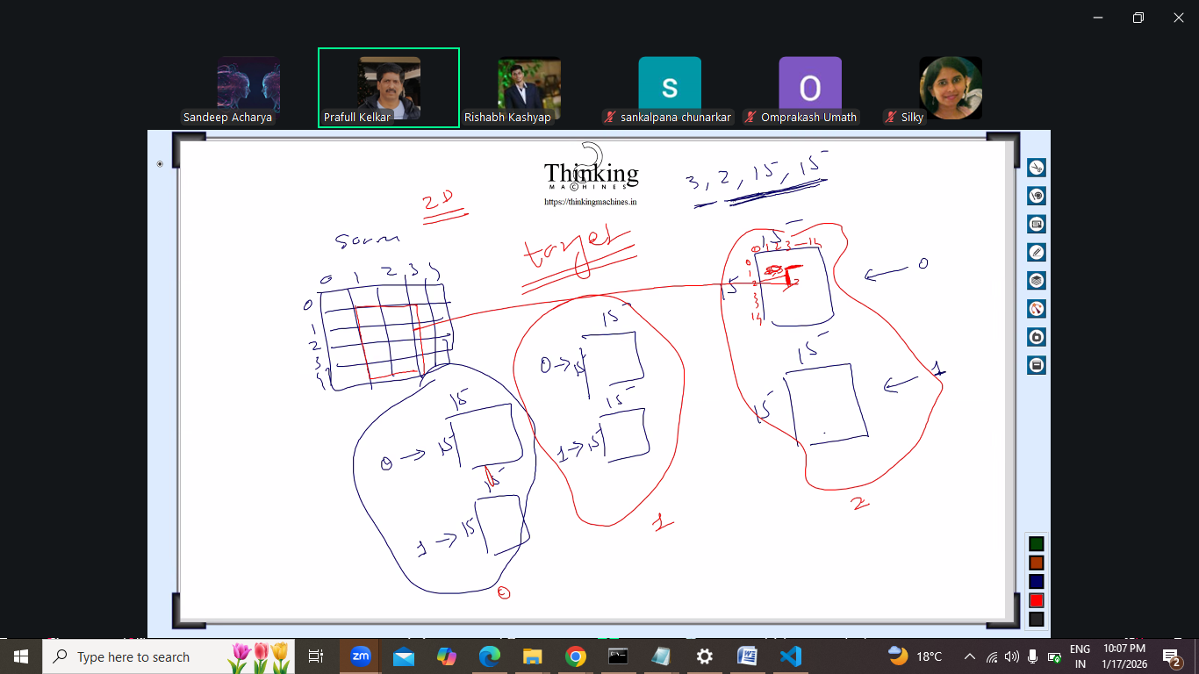
15*15 k 2 bnaye 0,1
and ese teen bnaye 0,1,2 in red har me 0,1 wala 3d
copy me ese conditions bdani pdegi
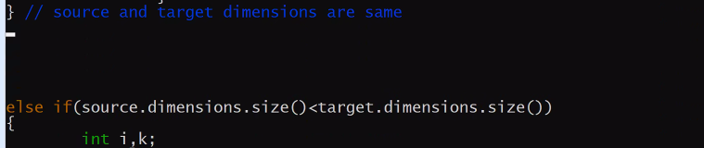
1,1
4,2
2,0,2,3

Last index =sourceform.size-1 = 1
1<2 so chlega
Uthayega rkhega chlega
Phir
Sourcefrom[1]++ to 2 ho jayeg and 11 converted to 12
But in target 2023 become 2123 coz 1 index wala update ho gaya.

Ya to alag alag last index le ya offset nikal k add krege.
Source offset and target offset

To vo jo if else if lagane wali bat kri vo nahi lgani pdegi.
Dono k dimension ki value same to offset 0
Kabhi source ka offset bada hoga kabhi target offset
Jaha bhi ++ kri he vaha source offset and target offset + kr k ++ krna he.

Jese is case me dekhe
Sourcefrom[1]++ to 2 ho jayeg and 11 converted to 12
But in target 2023 become 2123 coz 1 index wala update ho gaya.
target_tmp_indices[last_index]++; // meansiing move to next combination
source_tmp_indeces[last_index]++;
to targettmpindeice[lastindex+targetoffset]++ esa krega to
2024 hoga and ye sahi hoga.

aaj ka ass:
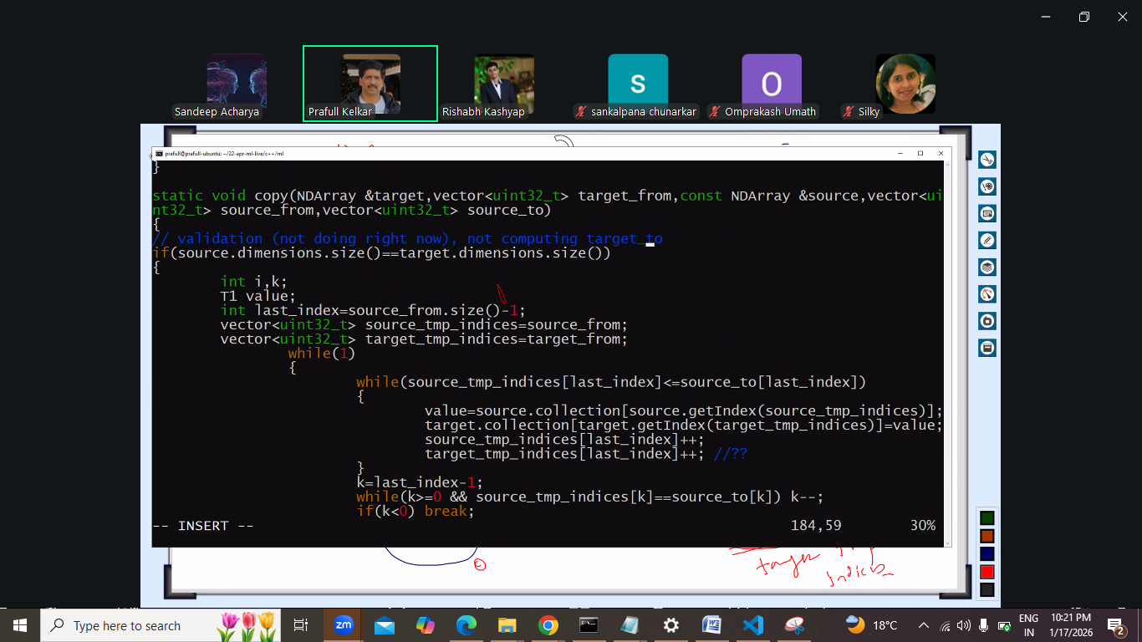
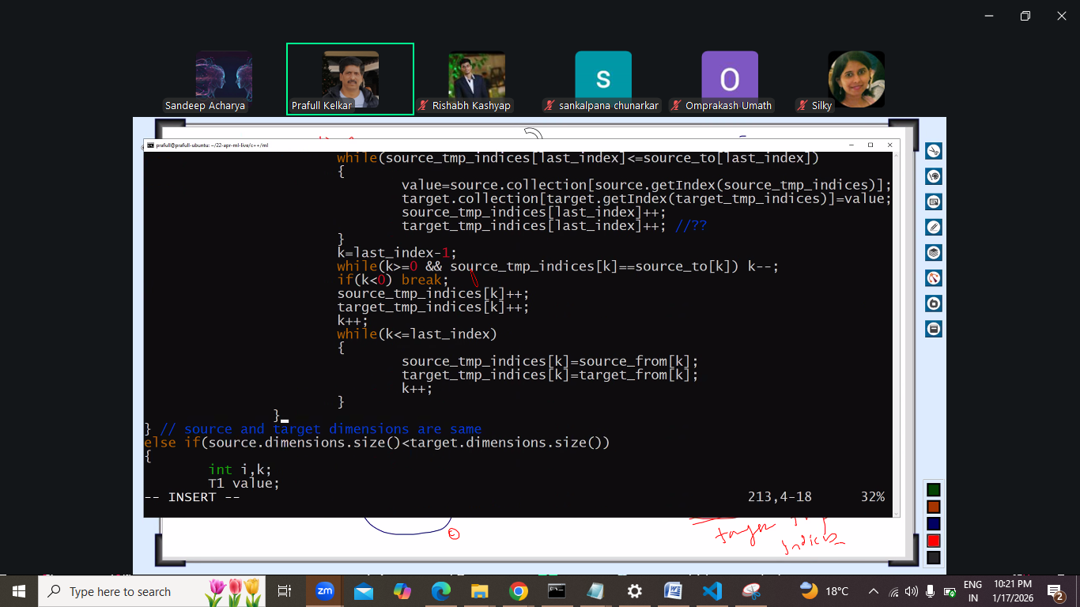

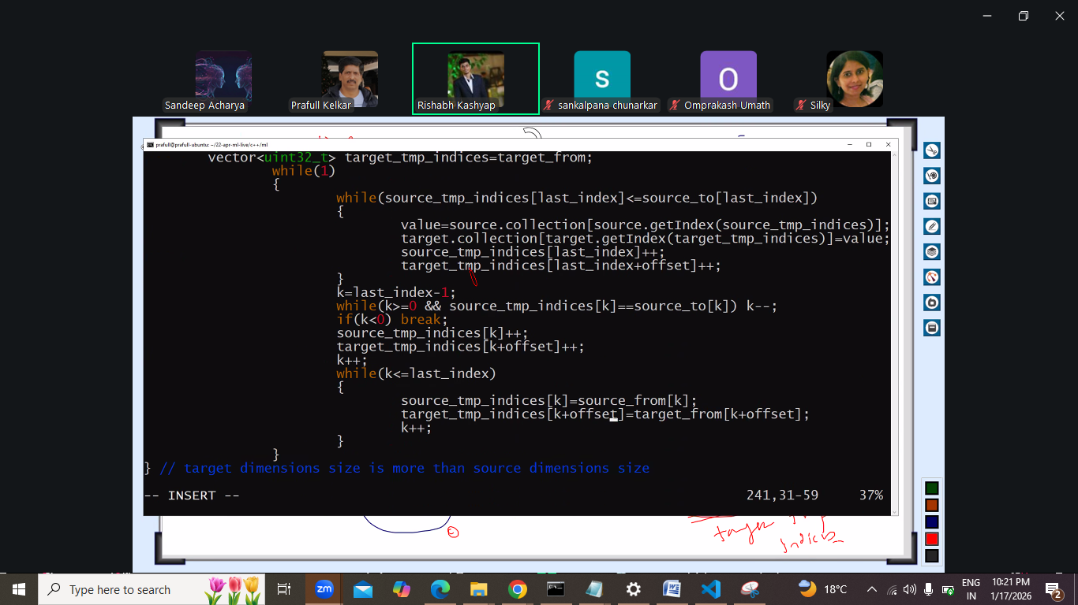
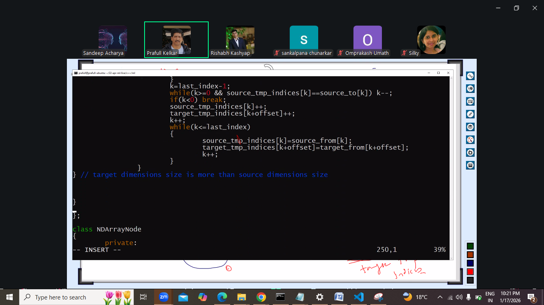
Is copy function ko chla k dena he next lecture.

Next: multithreading ki taraf:
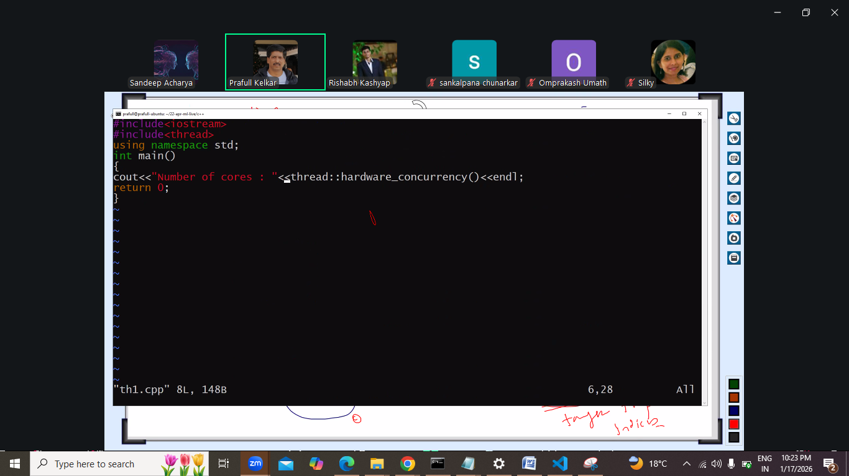
Jitney cores utne thread bnayege.
Esa kr k function ka naam diya and usko kya argument mile vo diya.
Note:
Isme alias wala feature use nahi krna he
Iski bjay idr & lagana he and reciewving pr star lagana he.
Kbhi bhi receiving pr & nahi lagaana
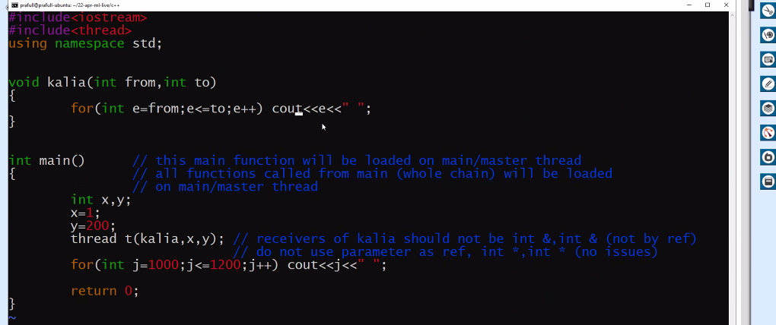
Thread t() se konsa function chla[ thread class ka pramaiterized constructor, and ye main thread pr chlega]
For loop me cout jis class ko represent kr raha he usme jo << wlaa function he jiska paramenter int type ka he vo bhi main pr chlega.
Pr jb kalia chlega vo sepaarete thread pr chlega, and us kalia k andr ki jinti bhi function call he vo bhi usi thread pr chlegi jis pr kalia chlega.

Note: konsa thread phle chlega and konsi baad me isko koi guarantee nahi he.
Ye depend krega context switch pr
Y is function k outpur se pt a chla jayega
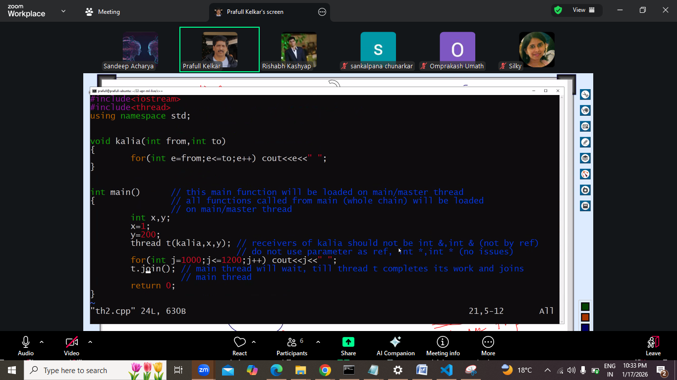
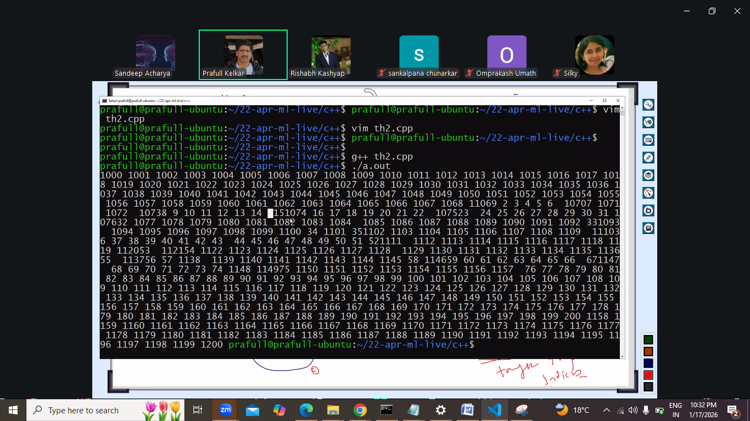
Cpp me koi virtual machine nahi he.
Yaaha dhyan rkhna he ki main tb tk khtm na ho jb tk child thread ka kaam khtm nahi hojata

Abhi us function ka maksad:
Kisis bhi function ko thread pr chlana he to thread claas ka object bnao , jis function ko chlana uska address do and us function ko jo argument chahiyee vo do and
Join () use kro taki vo main tb tk rhe jb tk function pura na ho jayega separate thread wala.
Kyuki cpp me virtual machine jesa nahi jesa java python me hota he.

Next:
Ab pta krna ki konsa thread kitna time leta he.
Th1. Core pta krna
Th2.
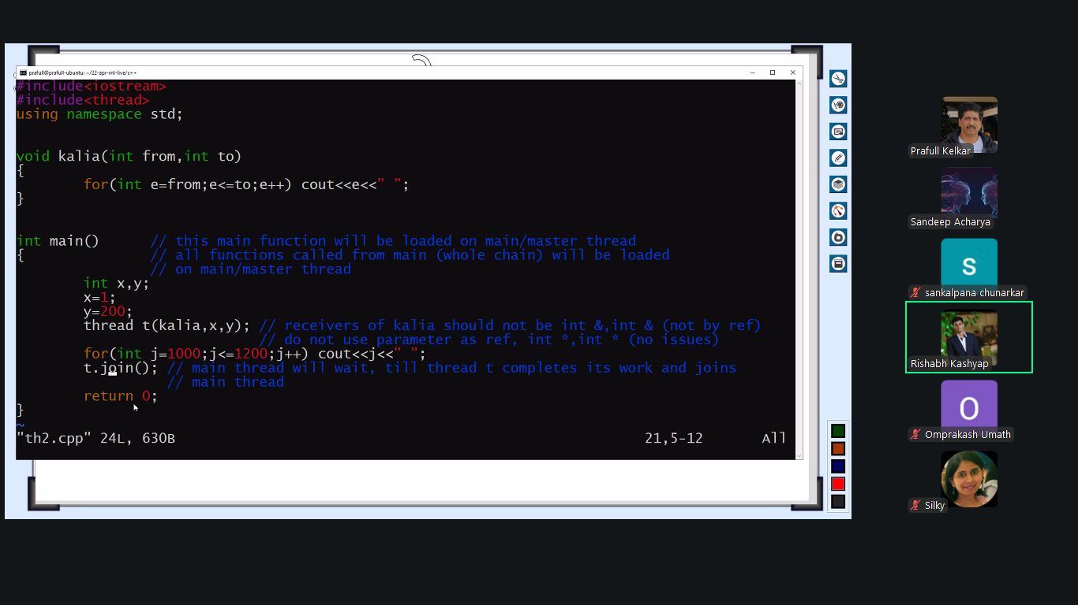

How create thread.
Th3.
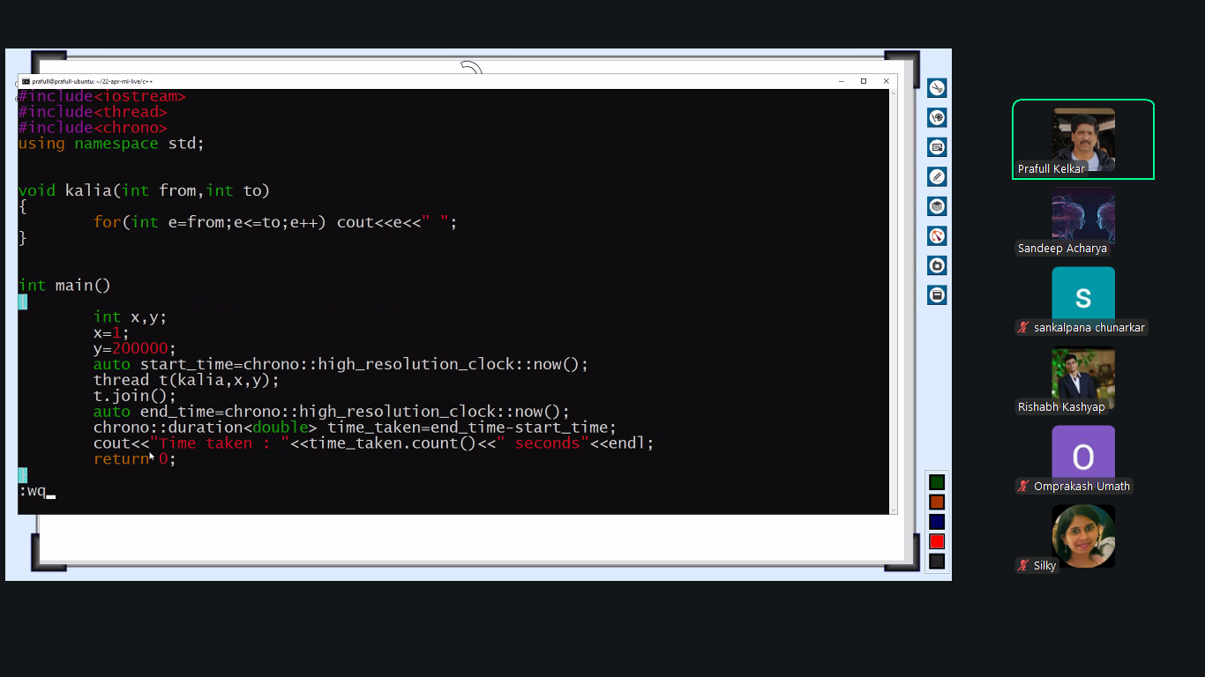
Time kitna lg raha he ye pta krna

Hamara task: how to distribute taks among multiple threads.

